Aug 13 2025 BDBP106: Linux and Python programming Lab 8
Ankita Bose’ PhD
EXERCISES Start a fresh terminal for this Lab and make a new directory called ’Lab8’.
Copy the ‘Braincancer.csv’ file to this directory. At the end of the lab, rename the data file as
‘Braincancer Lab8.csv’ and upload this to github as well.

1) Open the data file using the VIM editor.

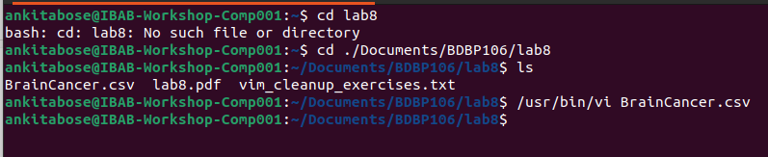
(2) Move to the beginning of the file and insert the text: ”VIM challenge begins!” on a new
line at the very top.

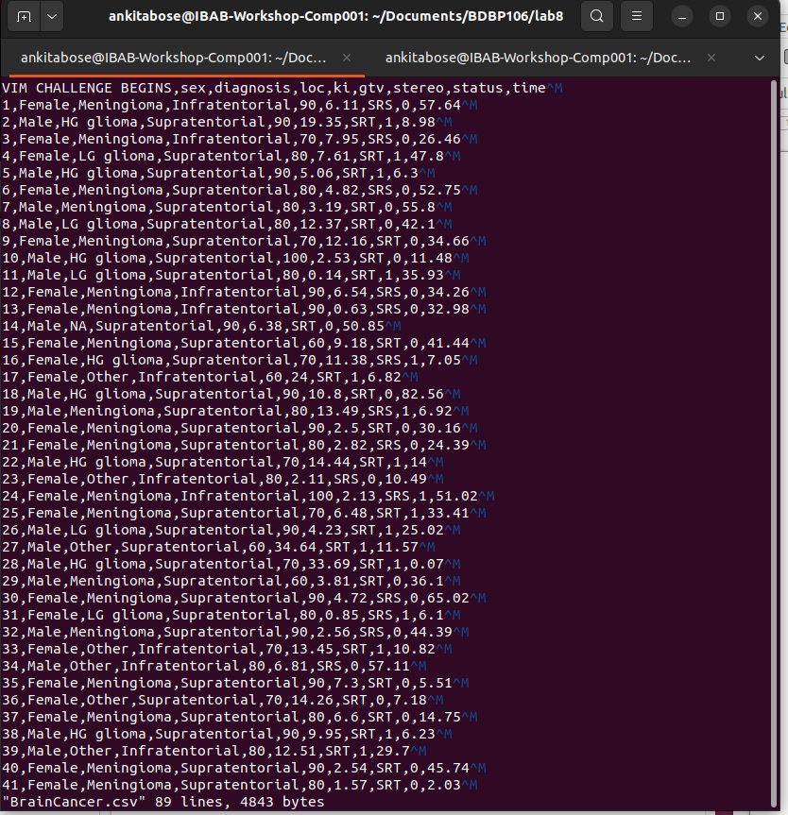

(3) Find the word ‘Meningioma’ and replace it with ‘LG glioma’
Command: :%s/Meningioma/LG glioma/g
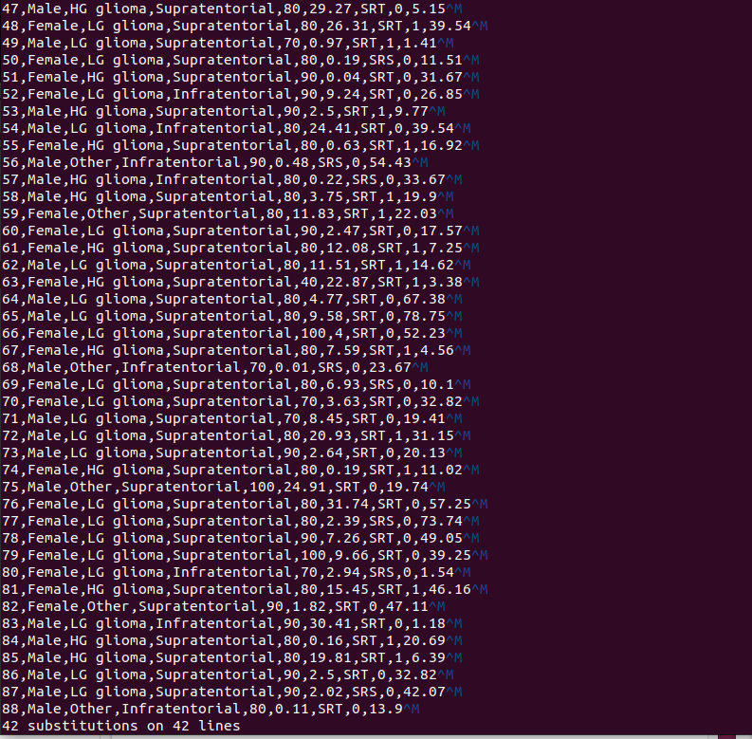

(4) Delete the entire line containing the time column entry ‘34.66’
First, search by typing :/34.66/ and then type dd for deleting the whole 9th line
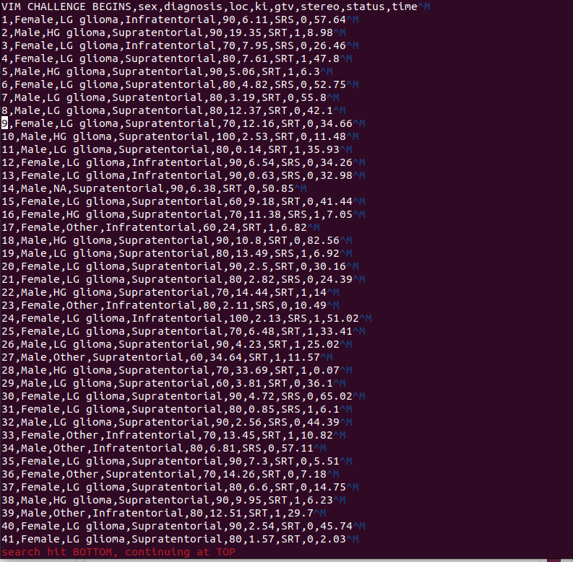
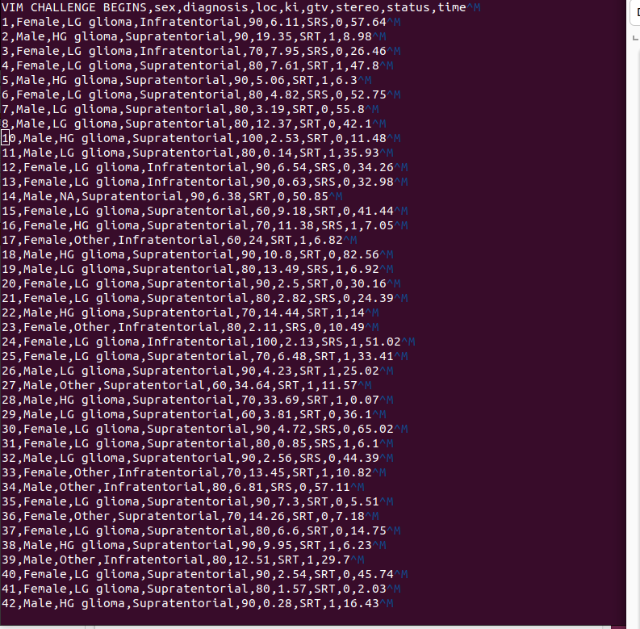
(5) Copy the current line and paste it two lines below. Show the screenshot before and after
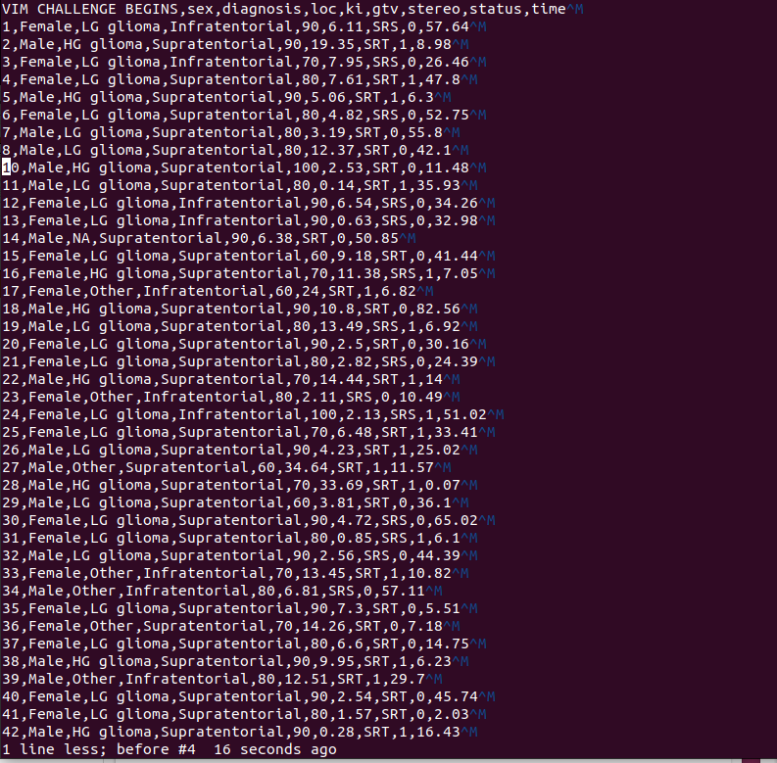
pasting with file line numbers to prove that you did it correctly.

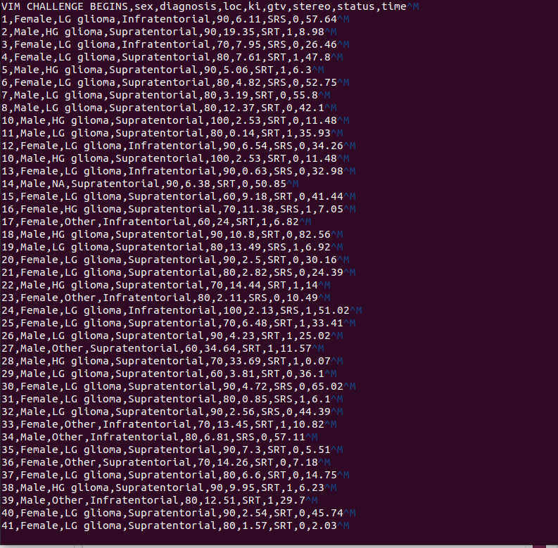
6) Move to the 11th line of this file and insert ”Hello from line 11!”
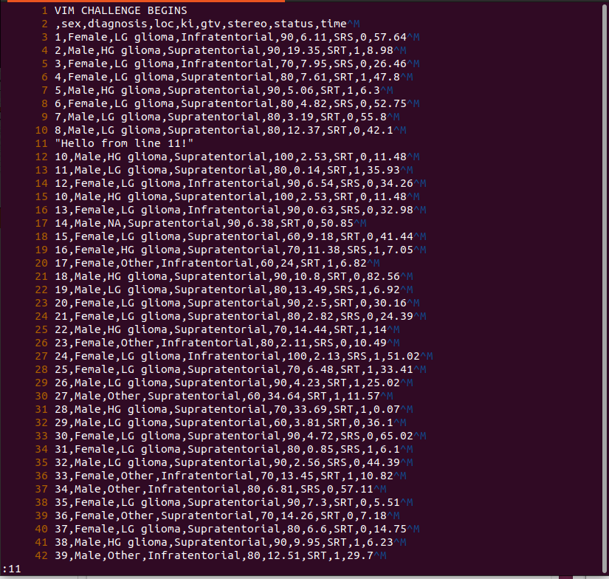
command: set nu to assign line numbers , “:11” to search the 11th line, “shift o” to include a blank line

(7) Search for the word ‘SRT’ and replace it with ‘SRS’ (all occurences in the file)
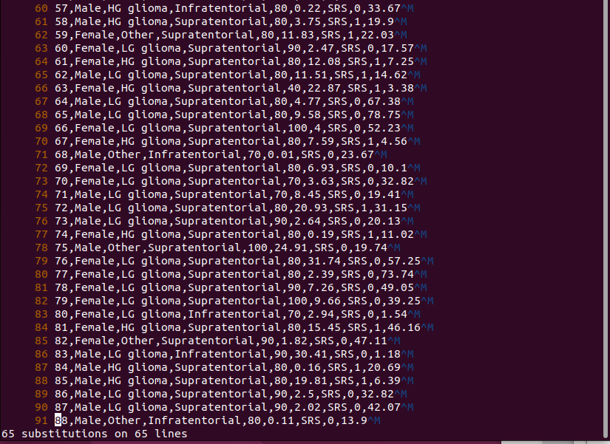
(8) Yank the first 3 lines of the file and paste them at the bottom
Go to the first line , 3yy , p at last line
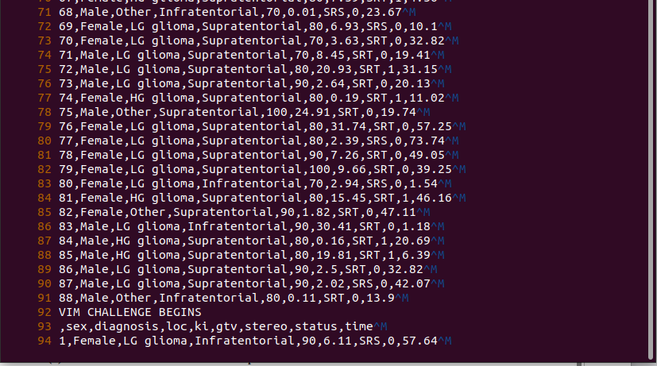

(9) Visually select this entire file list and indent it by two spaces.
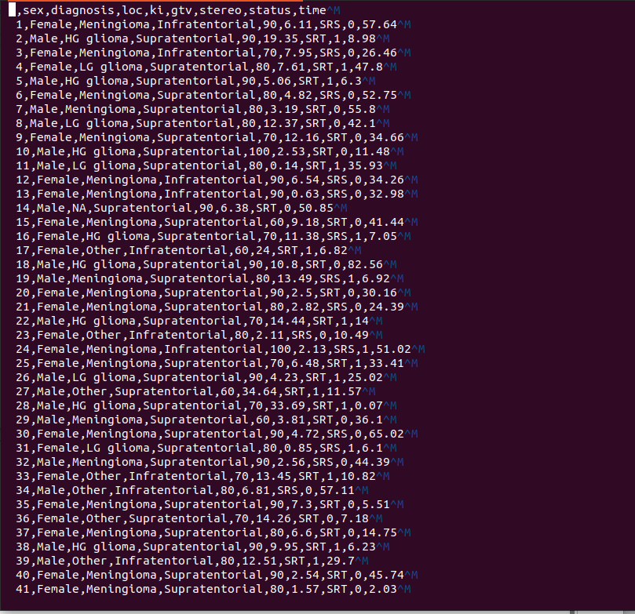

(10) Go to the 50th line number, and insert the following text: “ The cat sat on the mat.
Another cat was watching. The cat did not move.” Replace all occurences of the word
“cat” with ”tiger”

commands: shift A to go to the end of the particular line + insert mode, then wrote the text, select the particular line and then esp and then :s/cat/tiger/g so the cat in the whole line got replaced by tiger
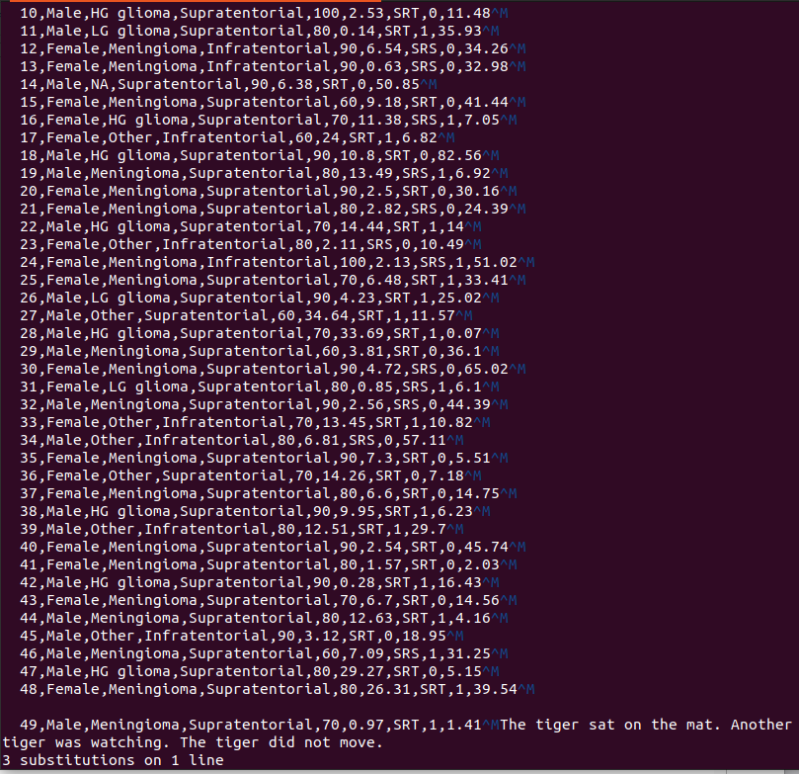
11) Insert the text “This is an important reminder for you.” at 70th line number. Then
change the word ‘important’ to ‘critical’. Describe the sequence of keystrokes used in
full

Commands: shift A and reach the end of the 70th line, which is 68th in my file then esp and “:s/important/critical “
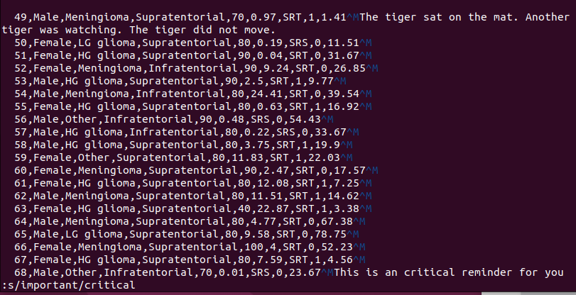
(12) Note down the current line number, jump to the end of the file and jump back to this
line without scrolling through every line. Describe the sequence of keystrokes used in
full
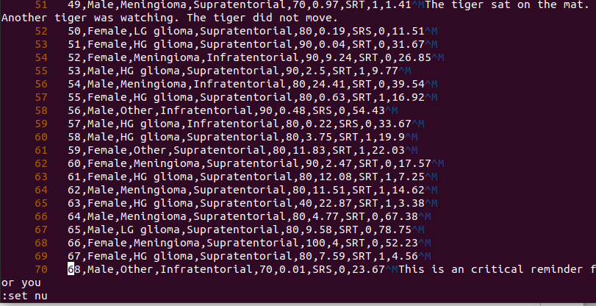
First assign the line numbers of file by “set nu” and then shift g for going to the first line of the file, then :”The line number (70)” and it goes back to the esteemed line.
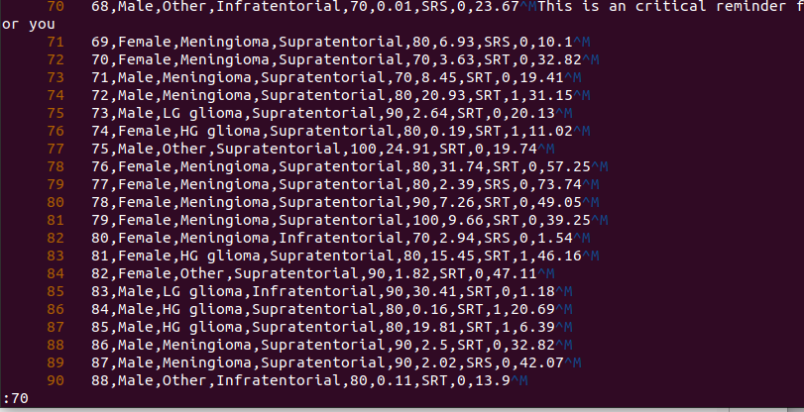
13) Add the following sentence at the end of the file: ”The quick brown fox (who was very
quick) jumps over the lazy dog.” Delete the text inside the parentheses (including the
parentheses) in the following text. Describe the sequence of keystrokes used in full.

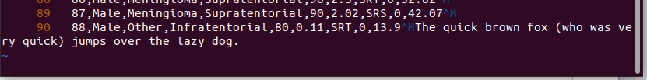
Shift g +shift a to go to the end of the line of the file and insert text

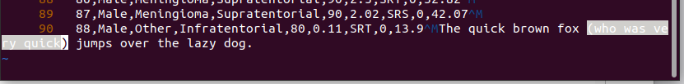
esp and control v and right arrow to select the words inside the parentheses
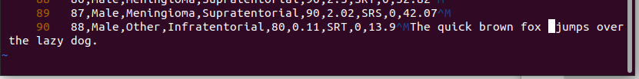
x to delete the whole selected words

14) Go to the last line of the file and append: ”– end of challenge”
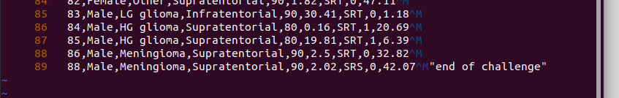

(15) In the remaining exercises, we are going to use Vim’s search, replace, visual modes and
text objects. Open the file vim_cleanup_exercises.txt and do the following. Describe
the sequence of keystrokes fully for each problem.
(i) Fix spacing issues in the text in the lines 1-3.
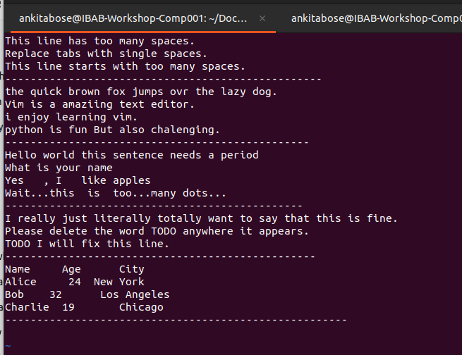
The spacing issue can be fixed by pressing the “x” key. Each “x” key will delete the space in the current position.

(ii) Fix any capitalization and typographical errors in lines 5-8.
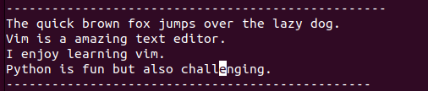

To fix the capitalization, the “r” key and the letter to be replaced is typed, which replaces the alphabets with our alphabets of interest. This fixes the capitalization issue.

For typographical error fixing, the key “a” in normal mode which changes the format to insert mode and the letter gets inserted in the cursor position.

(iii) Correct punctuation errors in lines 10-13.
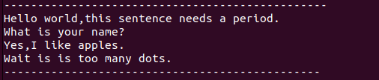

To remove the unwanted spaces “x” key can be used and to insert text “a” can be used.

(iv) Remove unwanted words in lines 15-17.
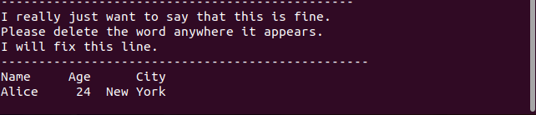
Has to be removed by selecting the text with ctrl v and shift right arrow and press x in 15th line. In 16 th line replace TODO with %s/TODO/ and removed by the key x.

(v) Fix alignment issues in lines 19-22.
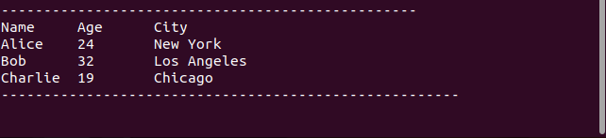

We have to go to before 24 to remove on space by x. Then beside 32 insert space by using key a. Do the same inserting spcaes before city names to align.

